**Day 19**

// Rate of interest calculating program using Abstract class and abstract method.

package com.java;

abstract class AbstractBank {

abstract float calcRateofInterest();

}

package com.java;

class AbstractBankSBI extends AbstractBank {

float calcRateofInterest() {

float principalAmount = 10000, time=2, simpleInterest =5;

float rate;

rate = simpleInterest*100/principalAmount*time;

System.out.println("Rate of Interest for SBI Bank is "+rate);

return rate;

}

}

package com.java;

public class AbstractBankCity extends AbstractBank{

float calcRateofInterest()

{

float principalAmount = 10000, time =2, simpleInterest = 2;

float rate;

rate = simpleInterest*100/principalAmount*time;

System.out.println("Rate of Interest for City Bank is "+rate);

return rate;

}

}

package com.java;

public class AbstractBankKotak extends AbstractBank {

float calcRateofInterest()

{

float principalAmount = 10000, time = 2, simpleInterest =1;

float rate;

rate = simpleInterest*100/principalAmount*time;

System.out.println("Rate of Interest for Kotak Bank is "+rate);

return rate;

}

}

package com.java;

import java.util.Scanner;

public class AbstractBankMain {

public static void main(String args[])

{

Scanner S = new Scanner(System.in);

System.out.println("Enter the Bank name ");

String input = S.nextLine();

AbstractBankSBI ob1 = new AbstractBankSBI();

AbstractBankCity ob2 = new AbstractBankCity();

AbstractBankKotak ob3 = new AbstractBankKotak();

if(input.equals("SBI"))

{

ob1.calcRateofInterest();

}

else if(input.equals("City"))

{

ob2.calcRateofInterest();

}

else if(input.equals("Kotak"))

{

ob3.calcRateofInterest();

}

else

{

System.out.println("Invalid. Please enter the correct bank name");

}

}

}

Output:

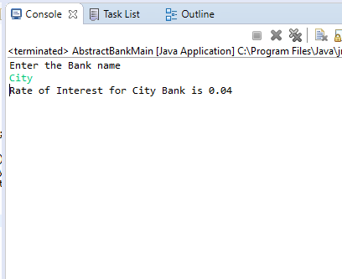

// Program for calculating salary of an employee using Abstract class

package com.java;

abstract class Salary {

abstract int calcSalary(int baseSalary, int hours);

}

package com.java;

public class SalaryFullTimeEmp extends Salary {

int calcSalary(int baseSalary, int hours)

{

int salary = baseSalary*hours;

System.out.println("Salary = "+salary);

return salary;

}

}

package com.java;

public class SalaryContractEmp extends SalaryFullTimeEmp{

int calcSalary(int baseSalary, int hours)

{

int salary = baseSalary*hours;

System.out.println("Salary = "+salary);

return salary;

}

}

package com.java;

import java.util.Scanner;

public class SalaryDisplay extends SalaryContractEmp {

public static void main(String ags[])

{

Scanner S = new Scanner(System.in);

System.out.println("Enter the type of employee ");

String input = S.nextLine();

SalaryDisplay ob = new SalaryDisplay();

if(input.equals("Full time employee"))

{

ob.calcSalary(10000, 10);

}

else if(input.equals("Contract"))

{

ob.calcSalary(5000, 5);

}

else

{

System.out.println("Enter a valid Employee ");

}

}

}

**Output**

